**ADMISSIONS EXAM-2023**

1. A 54-year-old gentleman presents to infectious diseases clinic for follow up of his tuberculosis treatment. He is concerned because he has found it difficult to see objects in the distance, in addition to worries that he has become colour blind. **Which of his medications is most likely to be causing this defect?**

a. Ethambutol ====================================

b. Isoniazid

c. Pyrazinamide

d. Rifampicin

e. Streptomycin

2. **Which of the following conditions is a recognized cause of lower motor neuron lesion of the facial nerve?**

a. Multiple sclerosis

b. Pseudobulbar palsy

c. Guillain Barre syndrome ===============================

c. Intracranial neoplasm

d.Sub-dural haematoma

3. A 62-year-old man was brought to the emergency room with history of retrosternal chest pain and sweating of two hours duration. The pain started at 3 am and awakened him from sleep. His ECG showed left bundle branch block.

**What is the best course of action?**

a. Aspirin, statin and thrombolytic therapy

b. Aspirin, statin, heparin and refer for coronary angiography ===============

c. CT-scan of the chest to rule out aortic dissection before giving thrombolysis

d. Aspirin, clopidogrel, statin, heparin and intravenous infusion of nitroglycerin

e. Aspirin, statin, clopidogrel, heparin and repeat ECG after 30 minutes

4. **Which of the following features suggests ventricular rather than supraventricular tachycardia?**

a. Ventricular rate >160 bpm

b. Termination of tachycardia with carotid sinus massage

c. Variable intensity of first heart sound =================================

d. Presence of heart failure

e. QRS duration < 0.14 second

5. A 65-year-old man is reviewed in the Emergency Department. Twelve months ago, he had a prosthetic aortic valve replacement for progressive aortic stenosis. over the past two weeks he has been complaining of lethargy, fever and anorexia. Blood tests show a CRP of 215 mg/l.

Given the suspicion of infective endocarditis, trans-esophageal echocardiogram is performed which demonstrates a large vegetative lesion around the prosthetic aortic valve.

**What is the most appropriate antibiotic treatment whilst awaiting blood cultures?**

a. IV amoxicillin

b. IV teicoplanin + vancomycin

c. IV flucloxacillin + low-dose gentamicin

d. IV vancomycin + rifampin + low-dose gentamicin ========================

e. IV teicoplanin + rifampicin

6. A 74-year-old man with a history of depression, chronic obstructive pulmonary disease and hypertension is admitted to hospital with severe central chest pain. He has no history of ischemic heart disease or similar chest pains in the past. On admission blood pressure is 160/98 mmHg, pulse 110/min, respiratory rate 18/min and oxygen saturation is 93% on room air.

A contrast CT chest is shown below:

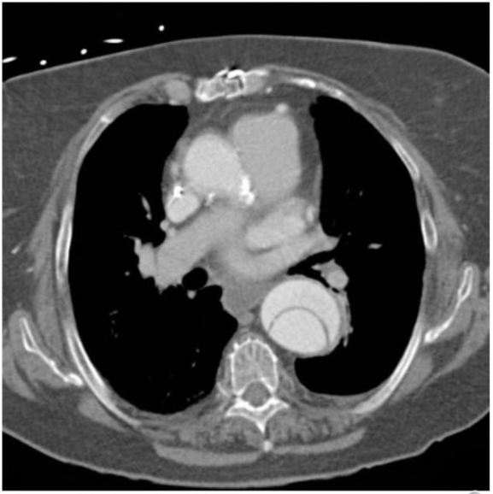

**What is the most appropriate immediate treatment?**

a. Chest drain

b. Cardiothoracic surgery

c. Intravenous labetalol ====================================

d. Thrombolysis with tenecteplase

e. Low-molecular weight heparin

7. A 56-year-old male with Heart Failure is reviewed in the clinic. He already is on Aspirin, Statin, Beta blocker and ACE Inhibitor.

**What other medication would be appropriate to add?**

a. Furosemide

b. Spironolactone ===============================

c. Hydralazine and isosorbide dinitrate (modified release)

d. Irbesartan

e. Ivabradine

8. A 68-year-old woman is brought into hospital after becoming severely short of breath accompanied with fever and productive cough. Observations on arrival include a respiratory rate of 25 breaths per minute, blood pressure of 85/53mmHg, heart rate of 103 beats per minute and oxygen saturation of 87% on room air. Blood urea is 19 mg/dl and AMTS is 7/10 with no previous confusion.

**What is the CURB-65 score for this patient?**

a. 1

b. 2

c. 3 ==============================================

d. 4

e. 5

9. A 23-year-old woman is referred with sudden onset of shortness of breath and pleuritic chest pain. She describes no cough or sputum. She is 24 weeks pregnant with her third child. On examination, she is slightly tachypneic at 21 breaths/min. Her blood pressure is 110/78 mmHg and her heart rate is 86/min. Her chest is clear and the JVP is not elevated and her heart sounds are normal.

The attending physician would like to exclude pulmonary embolism.

**What is the most appropriate investigation to do initially?**

a. Half dose CT angiography

b. V/Q scan

c. Doppler Ultrasound of legs ==========================

d. Full dose CT angiography

e. No need for investigation and start treatment with LMWH

10. A 25-year-old man presents to the Emergency Department with a two-day history of dyspnoea. His pulse is 84/min, respiratory rate is 18/min and oxygen saturation is 97% on room air. The trachea is central on examination. You review his chest x-ray:

**What is the most likely clinical diagnosis?**

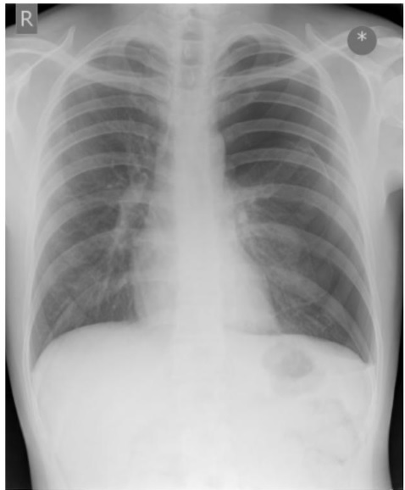

a. Left sided pneumothorax ===========================

b. Normal chest x ray

c. Left-sided tension pneumothorax

d. Hyper-expansion secondary to severe asthma

e. Right middle lobe pneumonia

11. A 70-year-old lady with a background of type 2 diabetes mellitus and alcohol abuse, presents with a fever and productive cough. She reports no weight loss or haemoptysis.

On examination, she has crackles in her right upper lobe but is otherwise well and stable. A chest radiograph reveals consolidation which is cavitating in her right upper lobe.

**What is the most likely diagnosis?**

a. Lung cancer

b. Tuberculosis

c. Pneumococcal pneumonia

d. Klebsiella pneumonia =============================

e. Aspergillosis

12. An 84-year-old gentleman with known metastatic lung cancer comes to the oncology clinic for review.

On examination, he has drooping of the right eyelid and the right pupil is smaller.

**What other features would be consistent with Horner's syndrome?**

a. Wasting of the small muscles of the hand

b. Ipsilateral loss of sweating of the face ========================

c. Supraclavicular mass

d. Inability to abduct the ipsilateral shoulder

e. Shoulder pain

13. A 68-year-old woman was admitted for an elective coronary angiogram. She had a past medical history of chronic kidney disease. Her blood results are below:

Urea 60 mg/dl, Creatinine 2 mg/dl.

**Which of the following measures is most likely to prevent this patient from developing contrast-induced nephropathy?**

a. Oral rehydration

b. Stop metformin

c. Haemodialysis following angiography

d. N-acetylcysteine

e. IV 0.9% Normal Saline ====================================

14. **Which of the following is a well-recognized cause of Polyuria?**

a. Hyperkalemia

b. Lithium Toxicity ===============================

c. SIADH

d. Addison's Disease

e. Hypocalcemia

15. **One of the following does Not cause hyperprolactinaemia:**

a. Chlorpromazine

b. Non-secreting hypothalamic tumour

c. Galactorrhea

d. Myxoedema

e. Bromocriptine =========================

16. **In Giardiasis, which of the following is true?**

a. Chronic infection may lead to steatorrhea ==========================

b. Most commonly presents with bloody diarrhea

c. Chloroquine is the treatment of choice

d. Transmission is by exposure to domestic animals

e. Easily diagnosed by examination of stool for trophozoites

17**. Which of the following is one of the main principles of medical ethics?**

a. Non-maleficence ===========================

b. Consent

c. Confidentiality

d. Competence

e. Euthanasia

18. A 27-year-old man was brought to the emergency room with fever, headache and disorientation. Brain CT-scan is normal. He needs urgent lumbar puncture and intravenous antibiotics. He is agitated and pushes away any one who tries to get near him. He was accompanied by his co-workers.

The medical resident could not perform lumbar puncture because the patient was uncooperative. You are the senior person on call.

**What should you do?**

a. Ask co-workers for consent

b. Wait for family members for consent

c. Do blood cultures only

d. Sedate the patient with lorazepam and perform lumbar puncture ==============

e. Order a brain MRI scan

19. In a trial of a new drug, the following results were obtained:

In the treatment group, 44 improved and 16 did not improve. In the placebo group, 36 improved and 26 did not improve.

**Which of the following statements is correct?**

a. Pearson’s coefficient of linear regression could be an appropriate significance test

b. A student t-test could be used

c. Results are obviously showing benefit of treatment, so that no statistical analysis is needed

d. The numbers are too small to draw any conclusion

e. The data could be evaluated using chi-squared test =======================

20. A 14-year-old student presented with history of recurrent chest infections and abdominal pain. There is a history of two blood transfusions in the past.

On examination: he had icterus and mild splenomegaly. Haemoglobin electropheresis shows increased HbF, increased HbA2 and S spike.

**What is the diagnosis?**

a. Sickle-cell disease ============================

b. Anemia of chronic disease

c. HbSC variant

d. Thalassemia

e. G6PD deficiency

21. **Which of the following drugs does Not worsen glucose control in patients with type-2 diabetes mellitus?**

a. Thiazide diuretics

b. Anti-psychotic drugs

c. Beta-blockers

d. Aspirin ===============================

e. Statin therapy

22. A 36-year-old man is brought to the out-patient department by his family because of intellectual decline over the last two months. Examination reveals slow Writhing movements with dystonic Posturing. His father has died of similar Illness.

**Which of the following is the most likely diagnosis?**

a. Creutzfeldt-Jacob disease (CJD)  
b. Wilson’s disease  
c. Syphilis  
d. Huntington disease ===============================  
e. Cerebellar degeneration

23. A 42-year-old woman presents with a three-week history of progressive fatigue, right upper quadrant discomfort, nausea, and jaundice. Her serum ALT level is 10 times the upper limit of normal.

**The presence of which of the following in a blood sample is most indicative of acute Hepatitis B virus (HBV) infection?**

a. Anti-HBc IgA

b. Anti-HBc IgG

c. Anti-HBc IgM ==========================================

d. Anti-HBsAg

e. HbsAg

24. A young girl presented to the emergency room with her father. She could not walk because of both lower limb pain. On examination there is a non-blanching rash on legs and buttocks. Urine analysis showed hematuria.

**What is the most likely diagnosis?**

a. Mixed connective tissue disease  
b. Haemolytic uremic syndrome  
c. Henoch-Schonlein purpura ===============================  
d. IgA nephropathy  
e. Nephrotic syndrome

25. **Which of the following is true regarding infection risk after elective splenectomy?**

a. Patients are at no increased risk of viral infection after splenectomy===========

b. Patients should be vaccinated 2 weeks after splenectomy

c. Splenectomized patients over the age of 50 are at greatest risk for post-splenectomy sepsis.

d. Staphylococcus aureus is the most commonly implicated organism in post-splenectomy sepsis

e. The risk of infection after splenectomy increases with time

26. **Which of the following joints is often spared by osteoarthritis?**

a. Cervical spine

b. Distal interphalangeal joint

c. Hip

d. Proximal interphalangeal joint

e. Wrist ==============================

27. **In autoimmune Addison’s disease, which of the following is Not true?**

a. The serum potassium concentration is characteristically low =============

b. There is an association with pernicious anemia

c. Weight loss is a recognized feature

d. There is an increased incidence of premature ovarian failure

e. Skin pigmentation is an associated feature

28. **Which of the following statements is correct?**

a. Abciximab is a glycoprotein IIb/IIIa receptor inhibitor ====================

b. Clopidogrel cause inhibition of thromboxane A2 release

c. Dabigatran is factor Xa inhibitor

d. Argatroban facilitates platelet aggregation

e. Warfarin is a vitamin-K agonist

29. **Which of the following infectious agents is the most likely etiology associated with an infected central venous catheter?**

a. Streptococcus pyogenes

b. Pseudomonas aeruginosa

c. Coagulase-negative Staphylococcus.=============================

d. Klebsiella pneumonia

e. Candida albicans.

 30. Serum biochemistry of a 60-year-old man revealed calcium of 8 mg/dl and phosphate of 1.5 mg/dl with an alkaline phosphatase of 450 IU/l.

**What is the most likely diagnosis?**

1. Osteoporosis
2. Osteomalacia==============================
3. Paget’s Disease of bone
4. Secondary Hyperparathyroidism
5. Renal failure

31.  A 25-year-old man presents with lethargy and increased skin pigmentation. Blood tests reveal deranged liver function tests and impaired glucose tolerance.

**Given the likely diagnosis of haemochromatosis, what is the most appropriate initial investigation strategy?**

1. Transferrin saturation + ferritin ==========================
2. Hematocrit + ferritin
3. Liver biopsy
4. Serum iron + ferritin
5. Serum iron + hematocrit

32. A 60-year-old woman presents with a 24 hours history of headache and vomiting. She has been on steroids for temporal arteritis for the last 3 years. Examination demonstrates pyrexia, neck stiffness, photophobia, dysarthria, nystagmus and ataxia. CSF shows neutrophilic pleocytosis, low glucose and elevated protein.

**What is the most likely diagnosis?**

1. Carcinomatous meningitis
2. Cryptococcal meningitis
3. Listeria meningitis   ==============================
4. Meningococcal meningitis
5. Tuberculous meningitis

33. A 25-year-old man was recently diagnosed with primary sclerosing cholangitis (PSC).

**Which of the following statements is correct?**

 a. Liver biopsy is diagnostic in most cases

b. Most patients have coexistent inflammatory bowel disease=================

c. Ursodeoxycholic acid reduces the risk of developing cholangiocarcinoma

d. Stenting of the bile duct improves survival

e. Stenting of the bile duct improves jaundice and survival.

34. A 65-year-old male, retired banker has well-controlled diabetes but persistently elevated blood pressure despite therapy with metoprolol and hydrochlorothiazide. His urinalysis now shows microabluminuria, but his creatinine is stable at 1.1 mg/dl. You start low-dose ramipril. Three weeks later, he returns to your office for follow-up. His blood pressure is better at 140/90, but his creatinine is now 1.8 mg/dL and his potassium is 5.2 mEq/L.

**What should you do next?**

a. Add a loop diuretic and order renal doppler studies

b. Start kayexalate immediately and repeat the potassium in one to two days

c. Discontinue ramipril and order an intravenous pyelogram

d. Change ramipril to irbesartan and add a loop diuretic

e. Discontinue ramipril and order a magnetic resonance angiogram of the Abdomen ===============================

35. A 36-year-old man presents with fatigue and pallor. He is found to have a hematocrit of 23%. His reticulocyte index is 4. You suspect a hemolytic anemia.

**Which of the following lab abnormalities is Notassociated with hemolytic anemia?**

1. An elevated haptoglobin level ==============================
2. An elevated lactic dehydrogenase (LDH)
3. An elevated indirect bilirubin
4. An elevated reticulocyte count
5. The presence of hemosiderin in the urine

36. A 16-year-old male student presents to hospital with decreased appetite, thirst, polyurea and weight loss over the last four weeks. One day prior to presentation, he felt weak and became lethargic. There is no history of previous illnesses.

Investigations: serum sodium 142 mEq/l, serum potassium 5.3 mEq/l, serum chloride 112 mEq/l, Serum bicarbonate 6 mEq/l, serum glucose 516 mg/dl, BUN 60 mg/dl, serum creatinine 2.2 mg/dl, PH 7.21, and positive aceto-acetic acid.

**Which of the following best describes the acid base state of this patient?**

a. Mixed respiratory and metabolic acidosis

b. Increased anion gap metabolic acidosis ===========================

c. Normal anion gap metabolic acidosis

d. Respiratory acidosis

e. Mixed metabolic acidosis and respiratory alkalosis

37. A 67-year-old woman was admitted to the ICU with multilobar pneumonia due to *Streptococcus pneumoniae* and COPD. She requires intubation and mechanical ventilation.

**Which of the following interventions you should Not do?**

a. Administration of enoxaparin 40 mg daily

b. Administration of omeprazole 20 mg daily

c. Aggressive blood glucose control between 70-140 mg/dl =================

d. Early mobilization and physical therapy

e. Intravenous broad spectrum antibiotics

38. A 62-year-old woman presented with abdominal pain, weight loss, early satiety and night sweats.

On examination, she was cachectic with enlarged lymph nodes in the supraclavicular area. A mass is palpated in the epigastric region. Haemoglobin: 8 gm/dl, white blood cells were normal.

**What is the most appropriate next step in establishing the diagnosis?**

a. Barium swallow and meal

b. Laparoscopic surgery

c. Lymph node biopsy

d. CT scan of the abdomen

e. Upper GI endoscopy and biopsy ===========================

39. **Which of the following features best distinguish Crohn’s disease from ulcerative colitis?**

a. Rectal bleeding

b. Oral ulcers

c. Continuous colonic involvement on endoscopy

d. Non-caseating granulomas ===========================

e. Crypt abscesses

40. **Which of the following is Not a cause of clubbing?**

a. Infective endocarditis

b. Biliary cirrhosis

c. Bronchiectasis

d. Atrial septal defect with left to right shunt=======================

e. Chronic lung abscess.

**===================Good Luck=====================**

**Must questions: 9, 10, 12, 13, 20, 23, 24, 36, 39, 40**